Incident Report Form
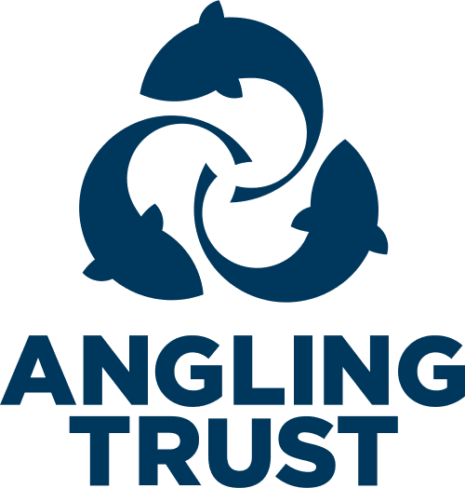

Use for reporting of concerns relating to poor practice, bullying, cases of emotional or physical neglect or abuse, or sexual abuse which have occurred at the Peper Harow Park Fly Fishers Club. Once completed, send this form to the Club Welfare Officer:
David Thorpe: Tel: 07796 178213 Email: davidathorpe02@gmail.com

- Name of organisation:
Peper Harow Park Fly Fishers Club
- Your name:
- Your position: (in the club – committee position or member)
- Your contact information:
Address:
Telephone number:
Email address:
- Name of Person of concern:
- Is the person under 18? (If no, go to question 12)
Yes
No
- Child’s date of birth:
- Parent/Carer’s name(s):
- Person or Parent/Carer’s contact information:
Address:
Telephone number:
Email address:
- Have parents/carer been notified of this incident:
Yes
No
- If YES, please provide details of what was said:
- Person’s gender:
- Person’s ethnic origin:
- Are you reporting your own concerns or responding to concerns raised by someone else:
Own concerns
Concerns raised by someone else
- If responding to concerns raised by someone else, please provide further information:
Name:
Position within club/event:
Telephone numbers:
Email address:
- Date and time of incident:
- Details of incident or concern: Include all relevant information, such as description on any injuries and whether you are recording this incident as fact, opinion or here say.
- Child’s account of the incident: Complete if this report relates to a child
- Please provide any witnesses accounts of the incident:
- Please provide details of any witnesses to the incident:
Name:
Position within club/event:
Telephone number:
Email address:

Name:
Position within club/event:
Telephone number:
Email address:

- Please provide any details of any person involved in this incident or alleged to have caused the incident/injury:
Name:
Person within the club or relationship to the child:
Date of birth:
Address:
Email address:

- Please provide details of action taken to date:
- Has the incident been reported to any external agencies?
Yes
No
- If YES, please provide further details:
Name of organisation/agency:
Contact person:
Telephone numbers:
Email address:
Agreed action or advice given:

Name of organisation/agency:
Contact person:
Telephone numbers:
Email address:
Agreed action or advice given:

Your signature: |  |  | Print name:
Date:
 |  | Reference No: (Please leave blank)
The Club Welfare Officer will contact the Angling Trust’s Designated Safeguarding Officer in line with reporting procedures. Richard.hadley@anglingtrust.net

